• Novels/Books •
1. GAPÔ (1980) - This novel explores the lives of ordinary citizens near the US Military bases and social issues or injustices in Olongapo City. It won the 1980 Palanca Grand Prize for the Novel in Filipino. Its complete title is “GAPÔ: at isang puting Pilipino, sa mundo ng mga Amerikanong kulay brown”.
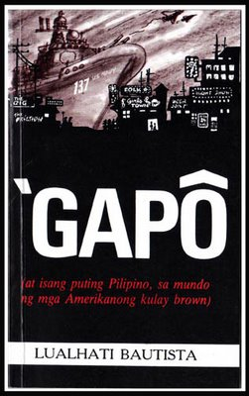

2. Dekada '70 (1983) - An historical novel follows Amanda Bartolome and her family as they live through the horror of Martial Law in the Philippines under Ferdinand Marcos. It won the 1983 Palanca Grand Prize.
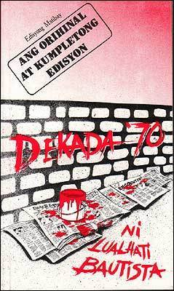

3. Bulaklak sa City Jail (1984) - Initially serialized from 1982 to 1983. This novel explores the harsh realities, struggles and sisterhood of women trapped inside the city jail.
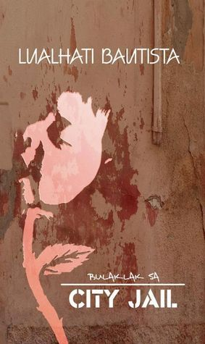

4. Bata, Bata...Pano Ka Ginawa? (1984) - The story centers on the Female lead, Lea Bustamante, a single working mother who balances her career, personal views and children while challenging traditional norms. It won the 1984 Palanca Grand Prize.
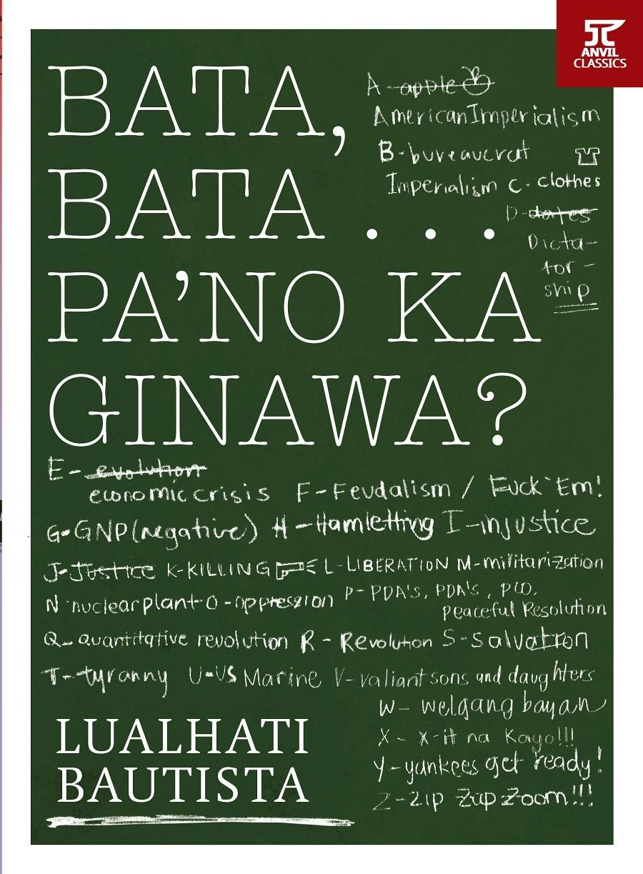
5. Ang Baliw (1991) - Ang Baliw is a psychological suspense story about two sisters, Lorna and Angela, whose traumatic family history and questions surrounding one sister’s death reveal the complicated relationship between mental illness, memory, guilt, and perception. It was published in 1991 under the Pinoy Suspense imprint.
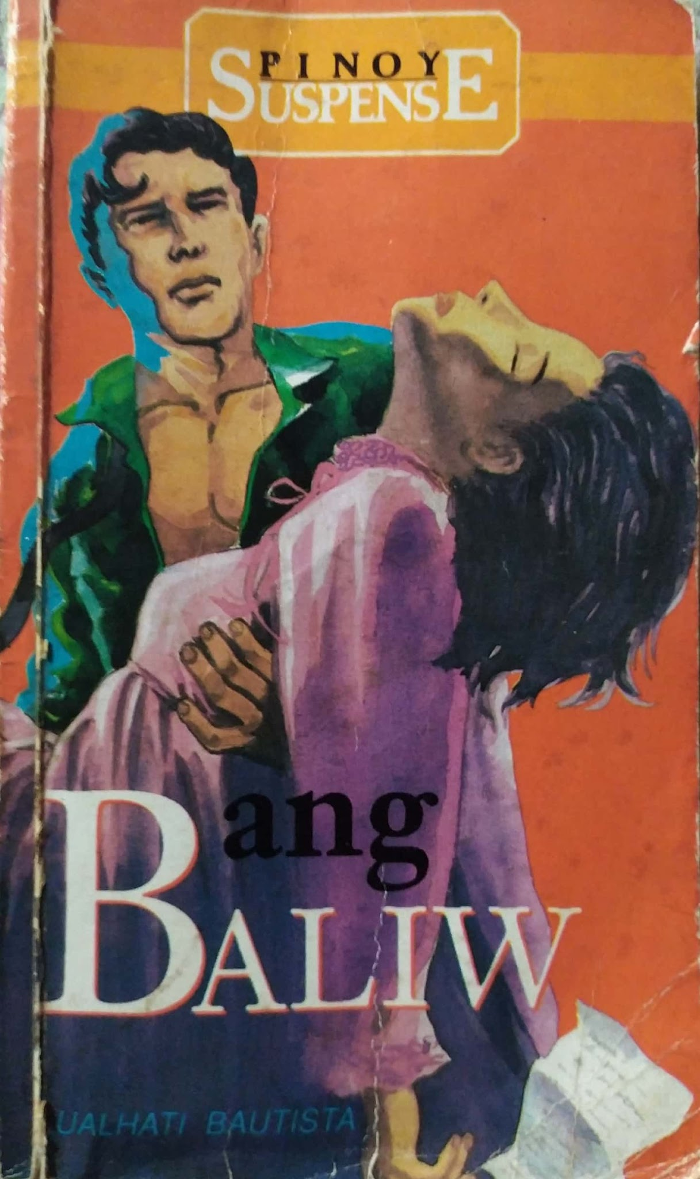

6. Sa Loob ng Walang Katapusang Gabi (1994) - About Efren and Raquel, two prisoners who develop a romantic relationship through letters and diary entries despite being held in separate prisons.
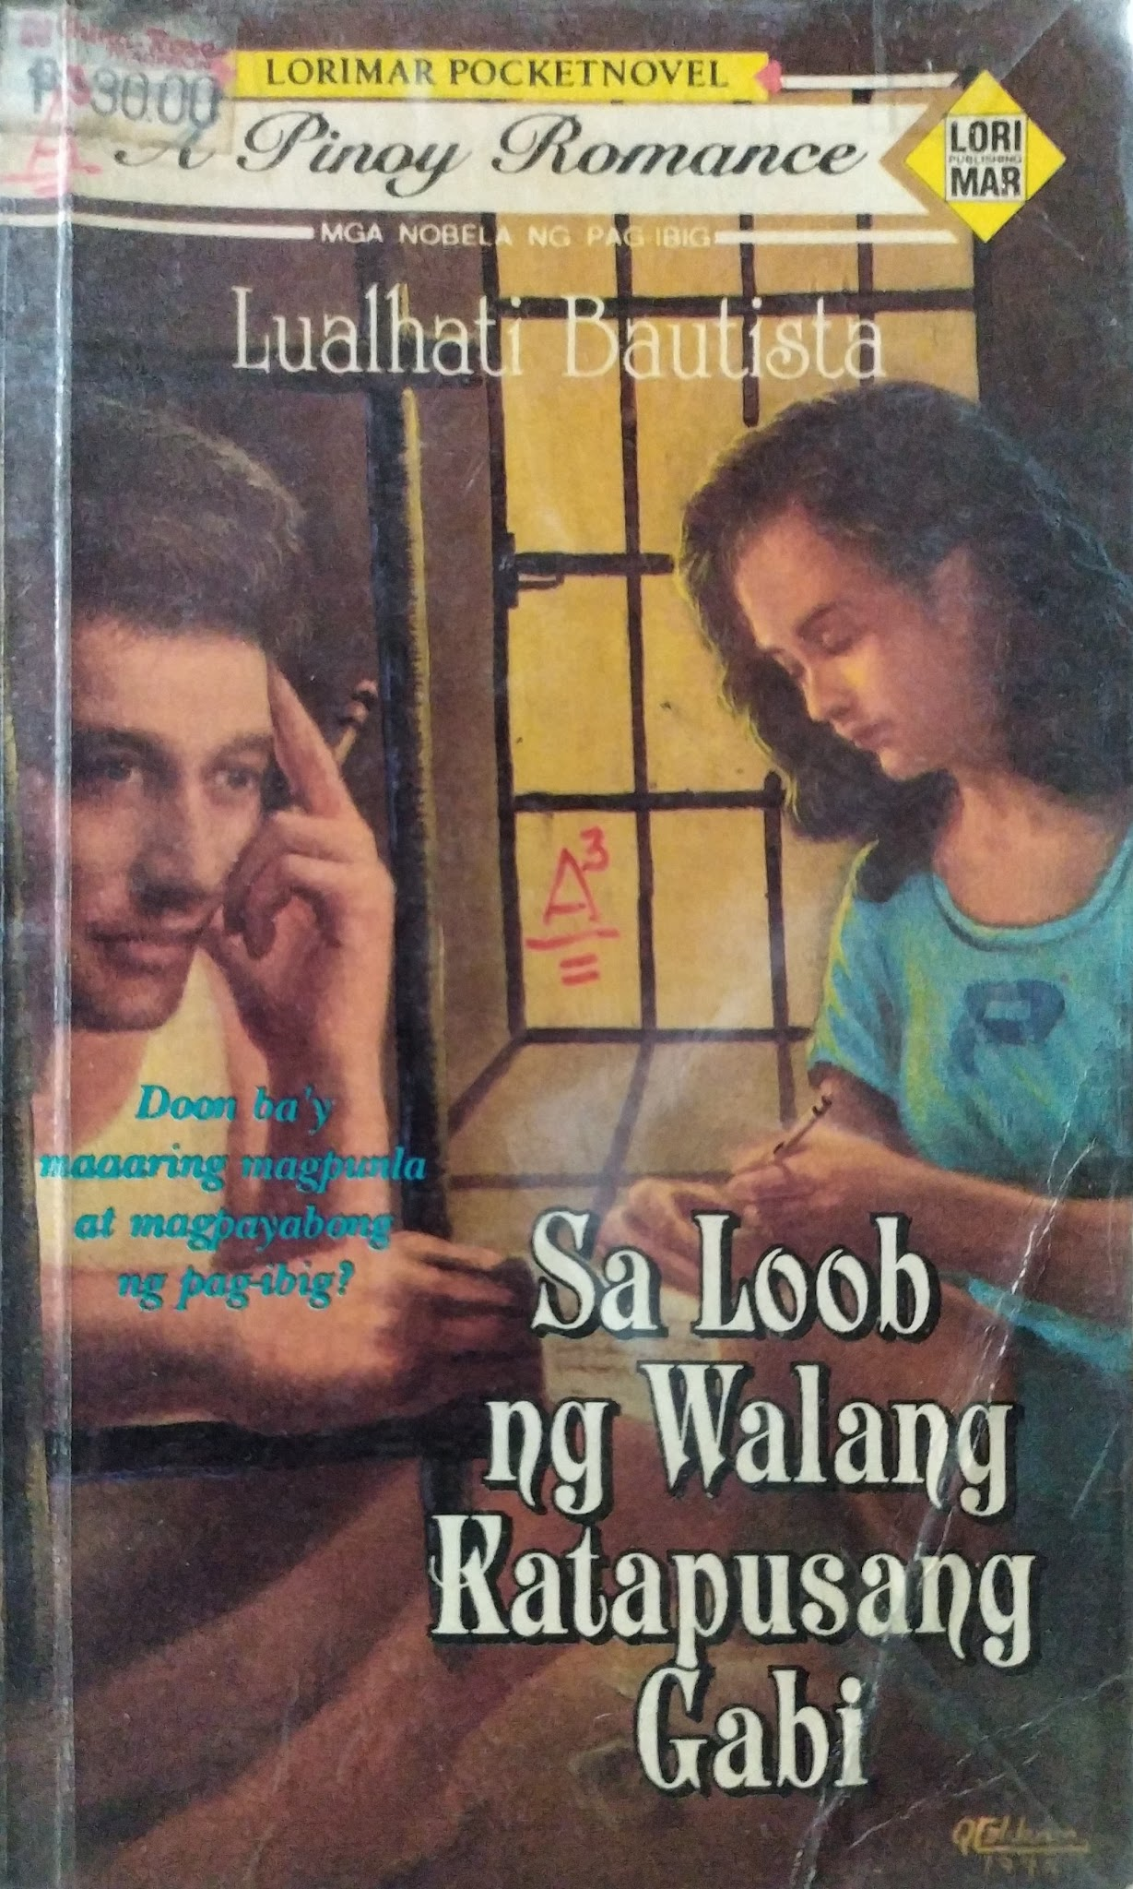

7. Desaperasidos (2006) - This novel tackles the painful aftermath of Martial Law by focusing on activists who search for their missing loved ones and dealing with the lingering trauma. It also appeared as a television work in 1998.
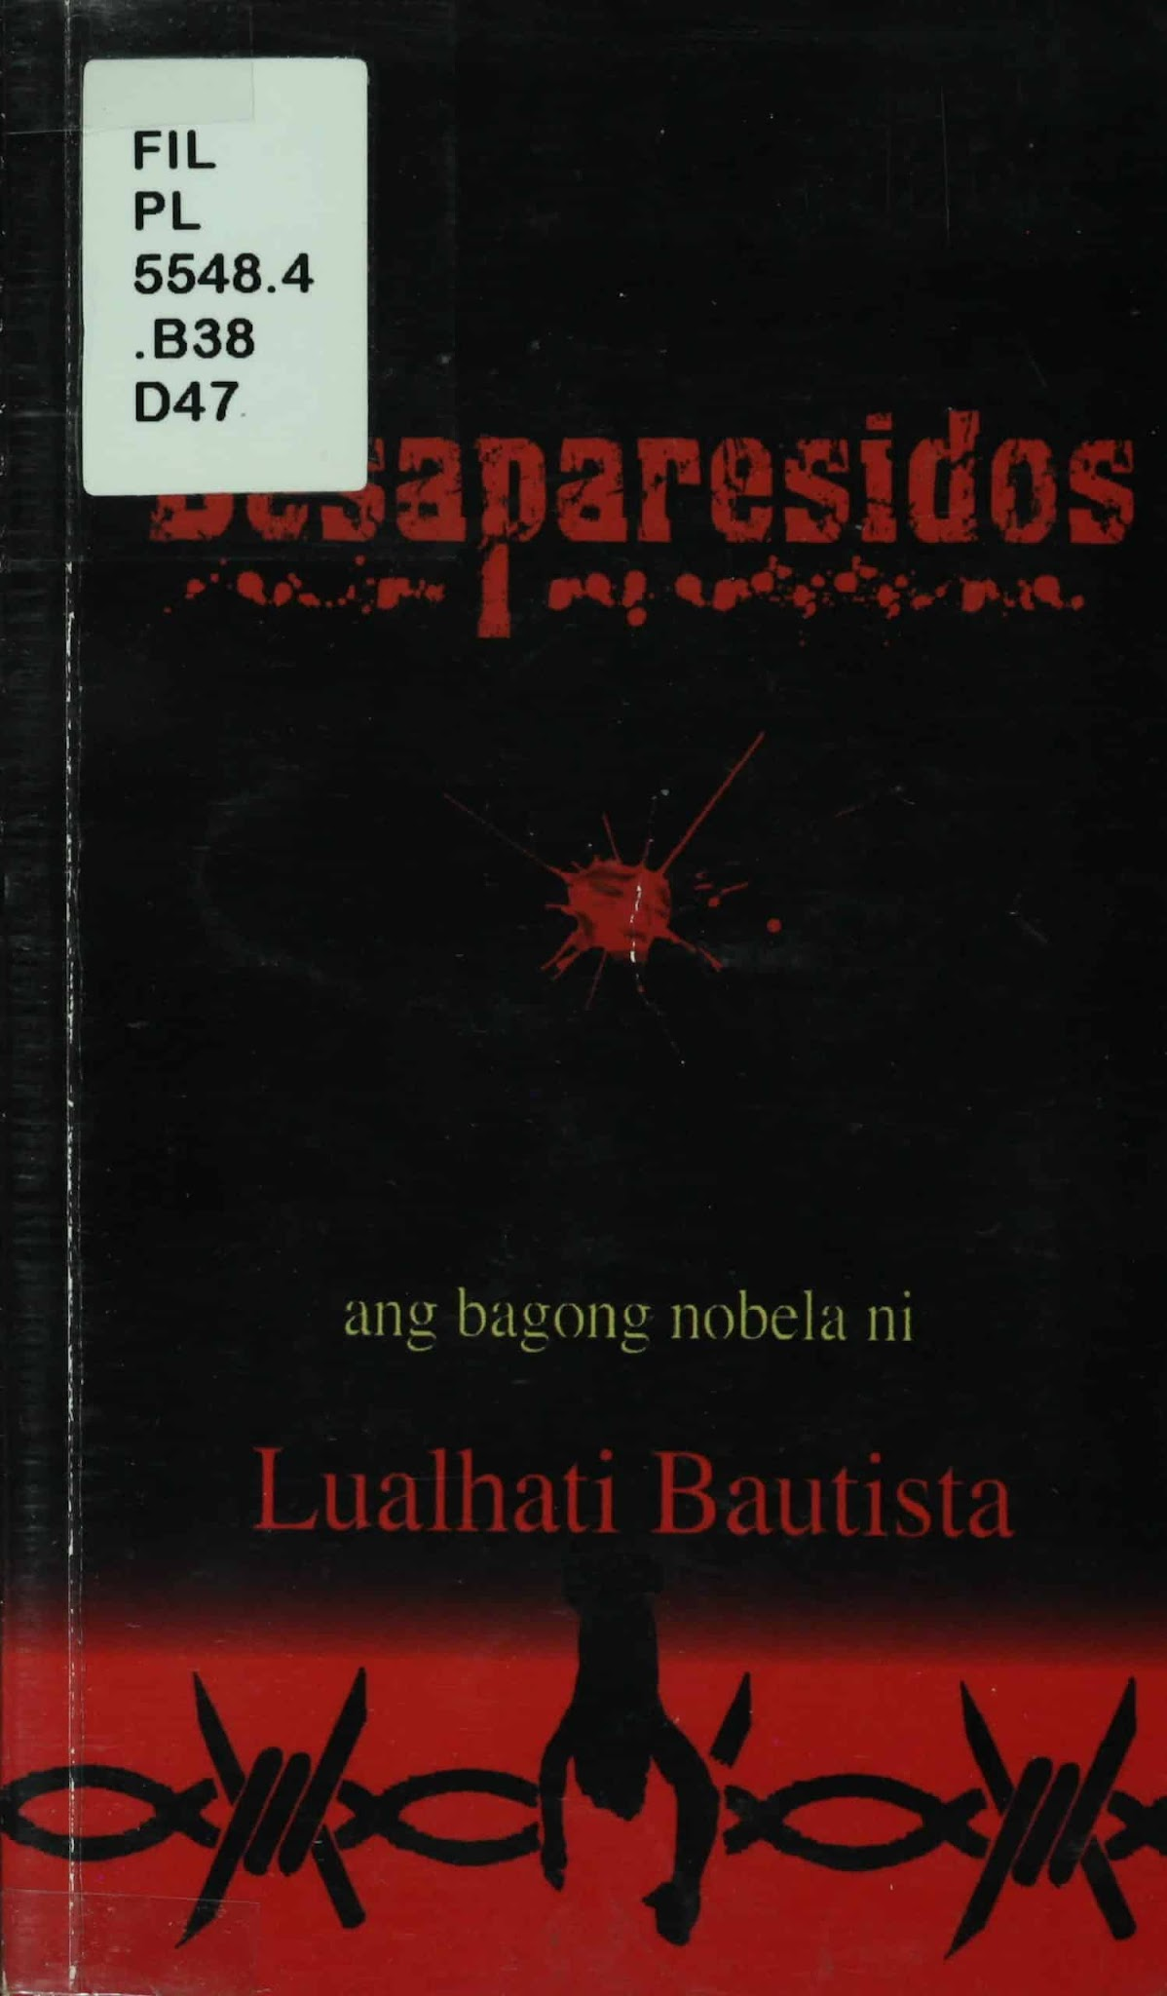

8. Sixty in the City (2008)- Centers on three women in their sixties discovering new perspectives on life, friendship and independence.
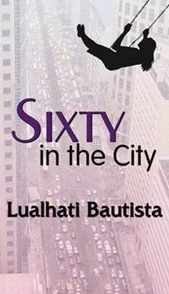

9. In Sisterhood (2013)- Explores women's relationships, solidarity, and experiences within a changing Philippine social environment
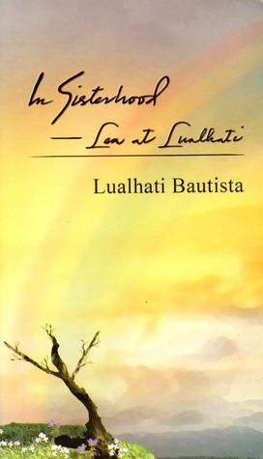

10. Sonata (2017)- Explores the deeper artistic and personal reflections of a writer navigating life and career.
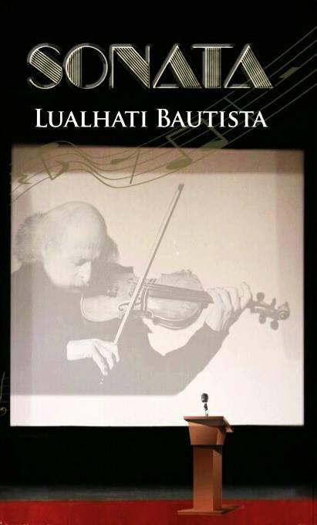

• Short Fiction •
1. Sila At Ang Gabi: Isang Buong Laot at Kalahati ng Daigdig (1994) - A shorter fictional work exploring relationships and the lives of its characters against a broader social backdrop.
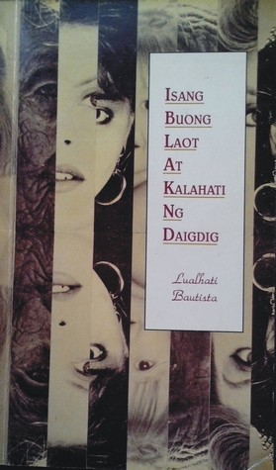

2. Ang Babae sa Basag na Salamin (1994) - A story centered on a woman confronting personal and social realities, particularly questions of identity and relationships.

3. Araw ng mga puso - shorter work dealing with love, relationships, and the realities surrounding romantic expectations.
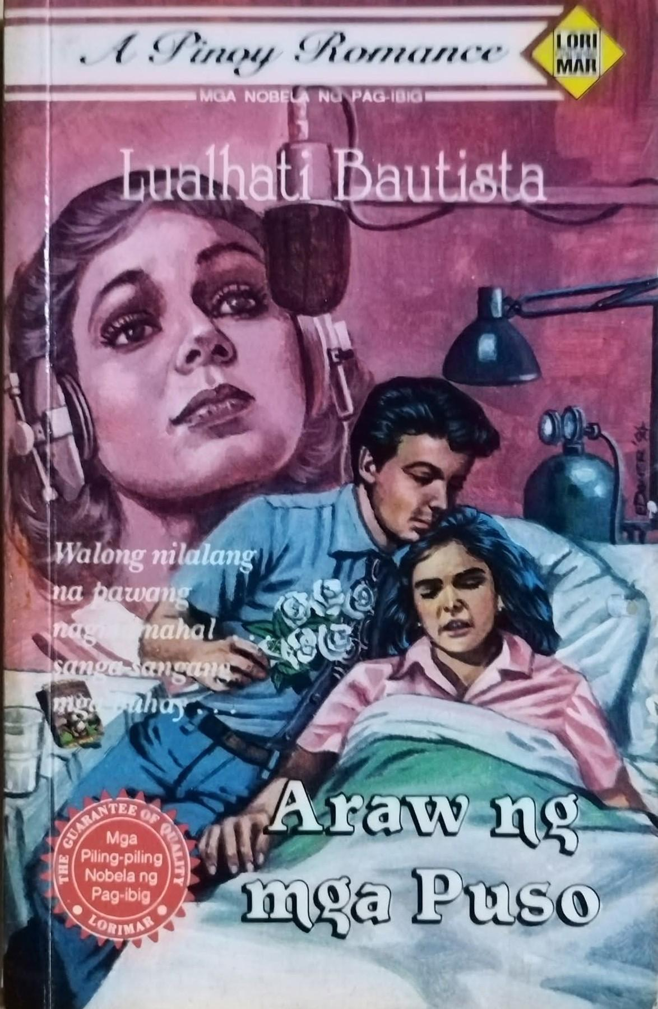

4. Ang Kabilang Panig ng Bakod (2005) - Explores the metaphorical and social boundaries separating people and their different experiences.

5. Hugot sa Sinapupunan (2004) - A shorter work dealing with family, identity, and personal experience.
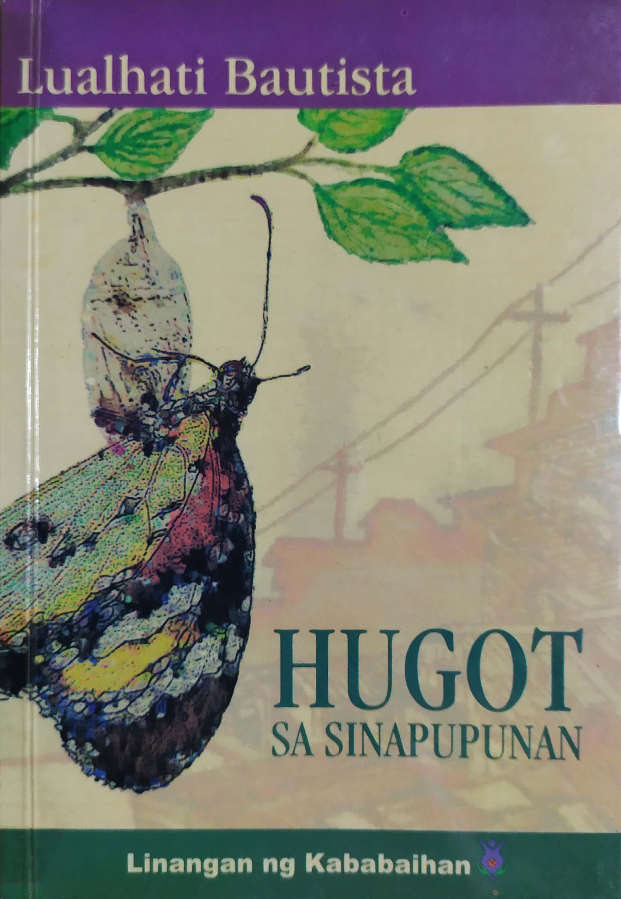

6. Desisyon - Focuses on difficult personal choices and their consequences.
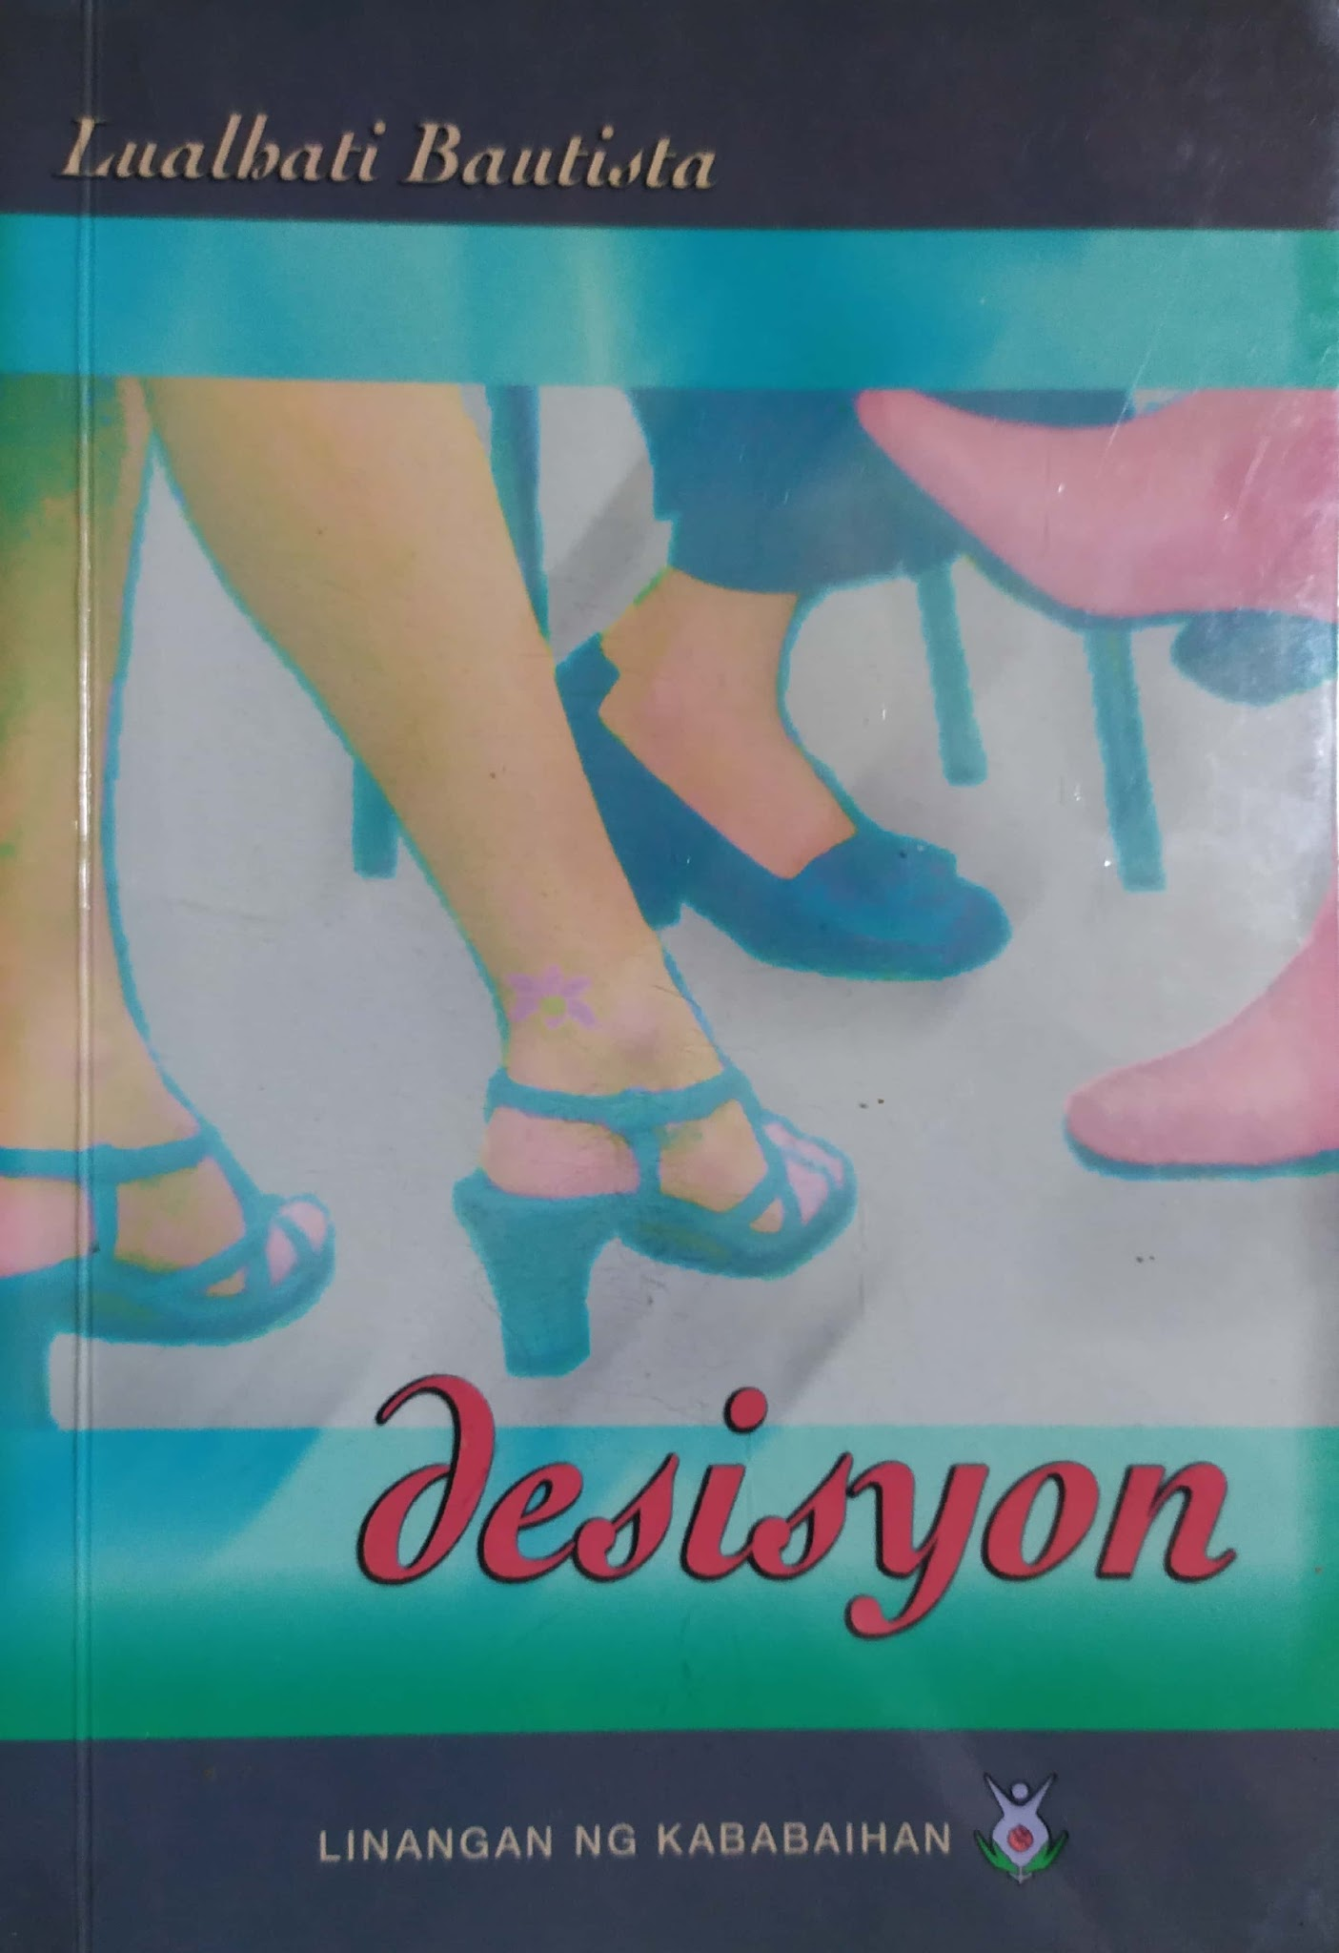

7. Sumakay Tayo sa Buwan - A shorter fictional work dealing with dreams, relationships, and escape from ordinary circumstances.
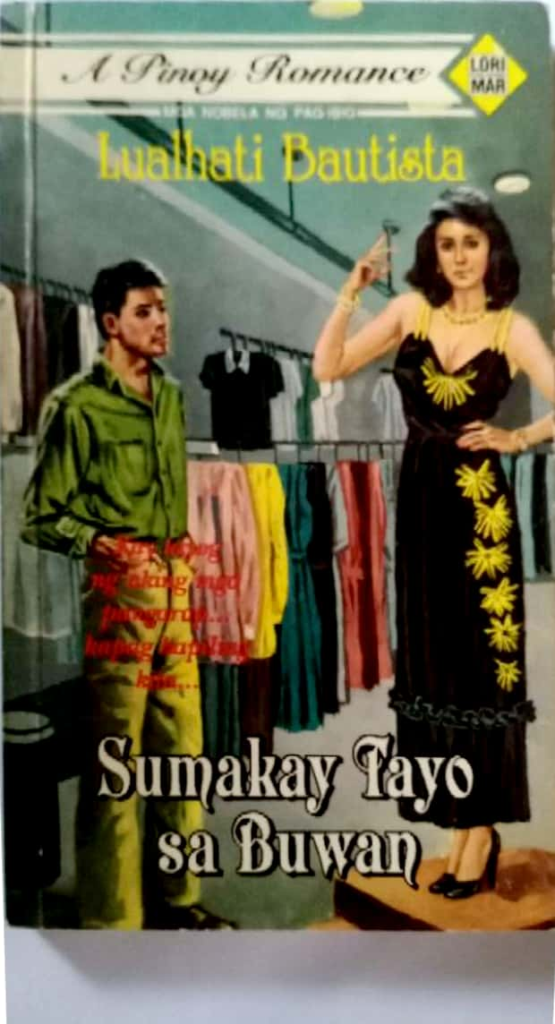

8. Apat na Screenplay (1997) - A collection of four Filipino screenplays that portray different social issues, human experiences, and realities in Philippine society. One of the works in the collection is “Maricris Sioson” by Lualhati Bautista, which presents the tragic story of a Filipina worker and highlights issues of exploitation, injustice, and the struggles faced by overseas Filipino workers.
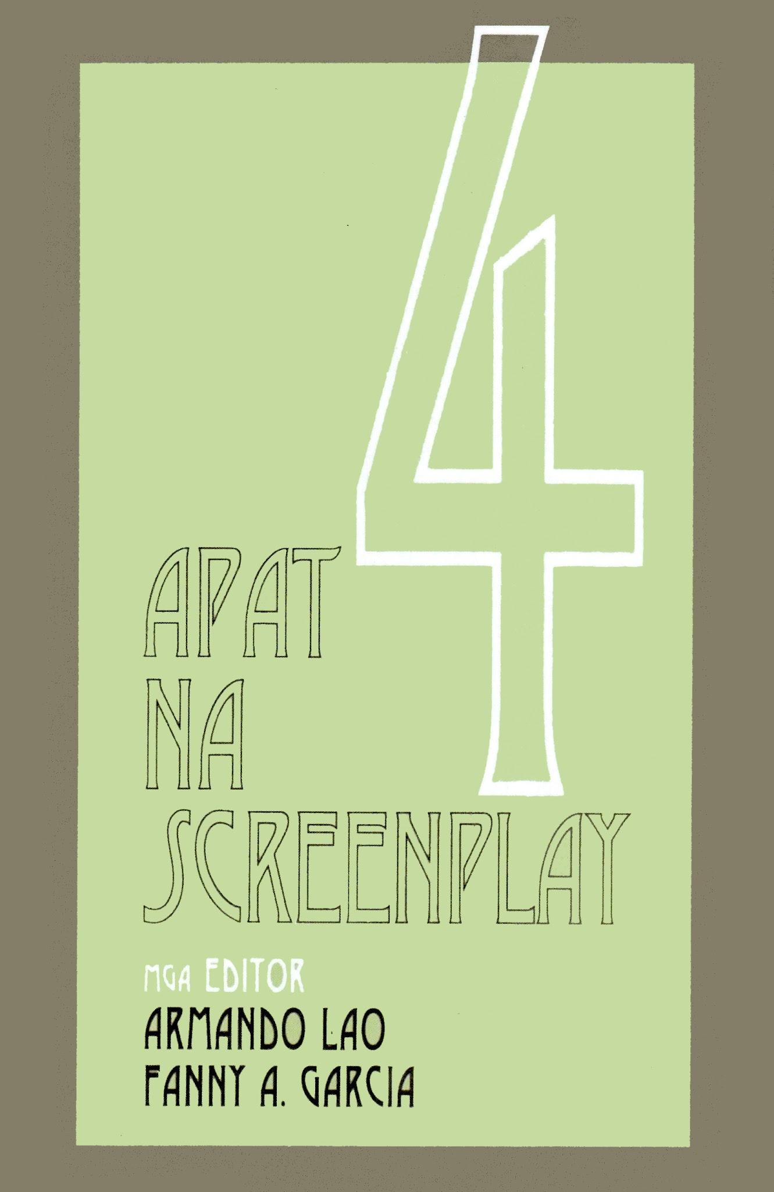
• Short Story Collection •
1. Buwan, Buwan, Hulugan Mo Ako ng Sundang: Dalawang Dekada ng Maiikling Kuwento (1983) - A collection representing roughly two decades of Bautista's short fiction. It brings together stories dealing with ordinary Filipino life, relationships, social inequality, and women's experiences. Won the Third Prize in the Palanca Awards for short story writing.
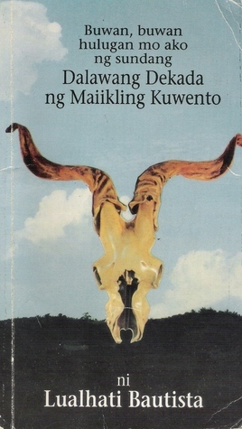

2. Ang Bayan ko - a short story that portrays the realities and struggles of Filipinos, highlighting love for one’s country, freedom, and social issues.
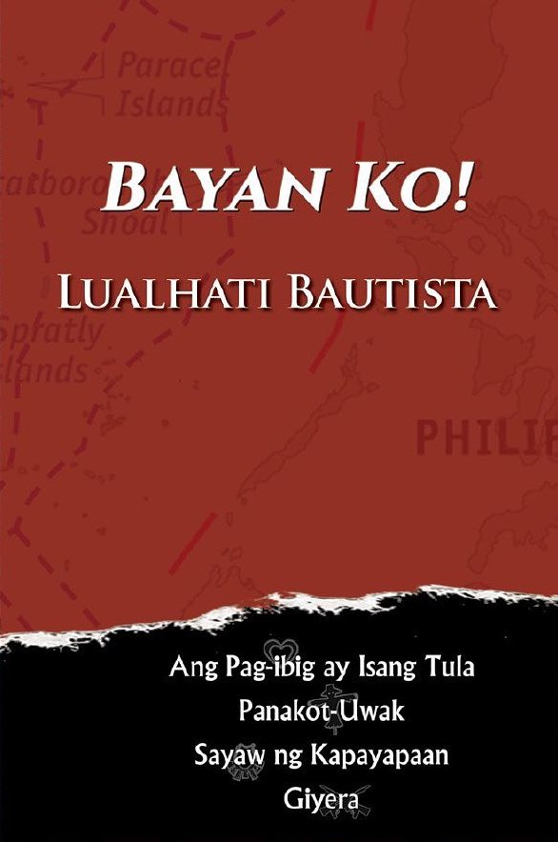

• Non-Fiction •
1. Hinugot sa Tadyang (2016) - The book is a feminist and social commentary that examines how Filipino women experience discrimination and oppression in society. Bautista discusses how gender expectations are taught from childhood through toys, fairy tales, beauty standards, media, advertising, and social traditions. It also tackles serious issues such as sexual violence, victim-blaming, discrimination, and the experiences of women during Martial Law. It was published by Dekada Publishing in 2016.
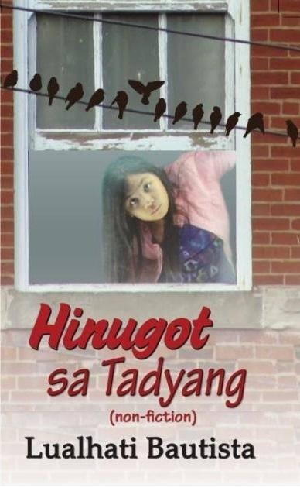

• Poetry •
1. Alitaptap sa Gabing Madilim (2020) - A collection of around 200 poems written by Lualhati Bautista over several decades, beginning as early as the 1970s. The poems explore love, grief, family, womanhood, death, political struggle, social injustice, and hope. Many of them are deeply personal, reflecting Bautista's experiences of loving, losing, remembering, and standing up for what she believes in. Other poems express criticism of government and society, particularly issues affecting women and marginalized people.
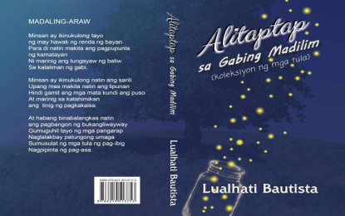
• Film Writing •
1. Sakada (1976) - Deals with the exploitation and difficult living conditions of Filipino sugarcane workers. The film was made during the early Martial Law period and was confiscated by the military.
https://youtu.be/Hpsu7lsZaB4?si=5EjkcgVY9mlbPKAt
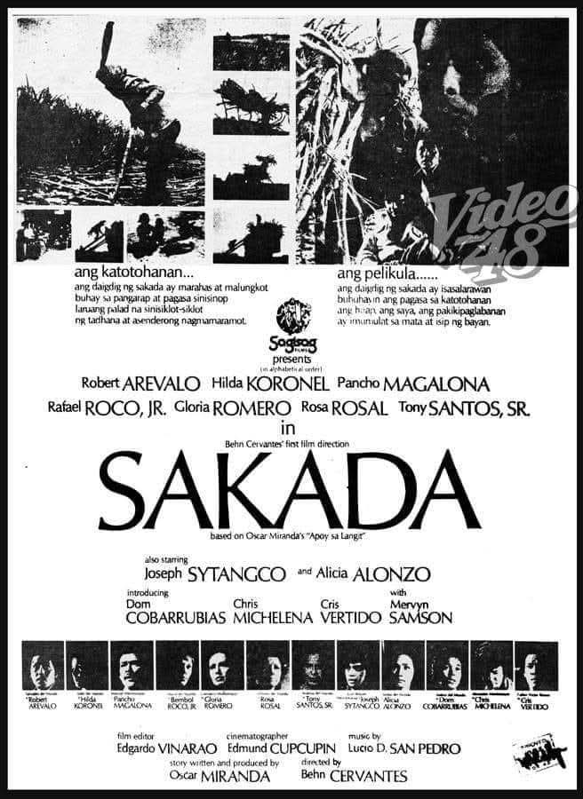
2. Kung Mahawi Man ang Ulap (1984) - A socially oriented film screenplay; the work was nominated for awards by the Film Academy of the Philippines.
https://youtu.be/nAjR8N3f3F8?si=fpj8d0aZfQs9cG6n
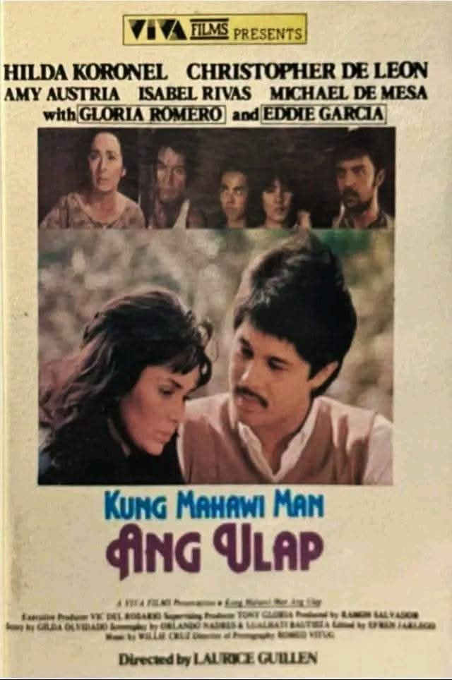
3. Bulaklak sa City Jail (1984) - A powerful story about women prisoners and life inside a city jail. It won Best Story and Best Screenplay at the 1984 Metro Manila Film Festival.
https://youtu.be/E07WrvWDi3o?si=D_SkFMwROq-jv_RF
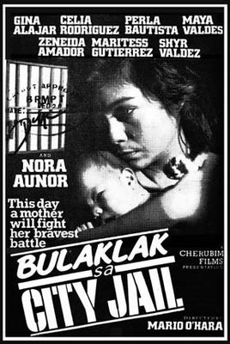

4. Kadenang Bulaklak - A screenplay dealing with social and personal struggles, particularly those faced by women.
https://youtu.be/glSXSQhNFYY?si=s6uZpGaL7g-23l3u
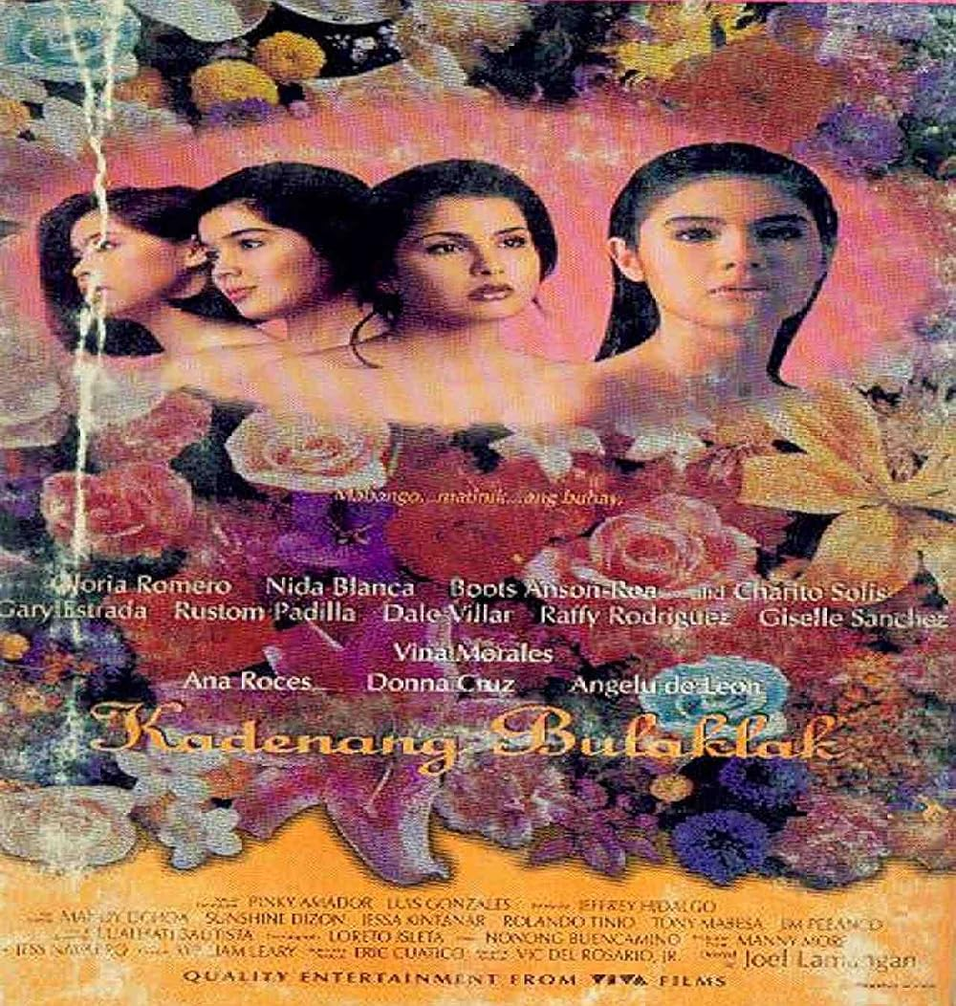

5. The Maricris Sioson Story (1993) - Lualhati Bautista wrote the screenplay for the 1993 film, directed by Joey Romero. The film is based on the true story of Maricris Sioson, a young Filipina who went to Japan to work as an entertainer in hopes of helping her family. After several months, she was hospitalized and died. Although her family was told that she died of hepatitis, they discovered injuries on her body when her remains were returned to the Philippines, raising questions about the circumstances of her death.
https://youtu.be/-mbM_IcqRvA?si=zXwfFhnsqf1afm6T
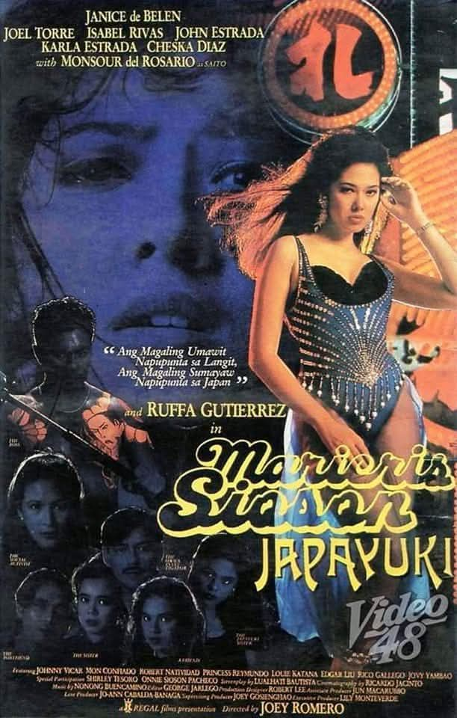
6. Nena (1995) - a dramatic work that focuses on a woman named Nena and the difficult circumstances surrounding her life
https://youtu.be/wIuJiMjvefA?si=vhGjilVvtH-sB4nS
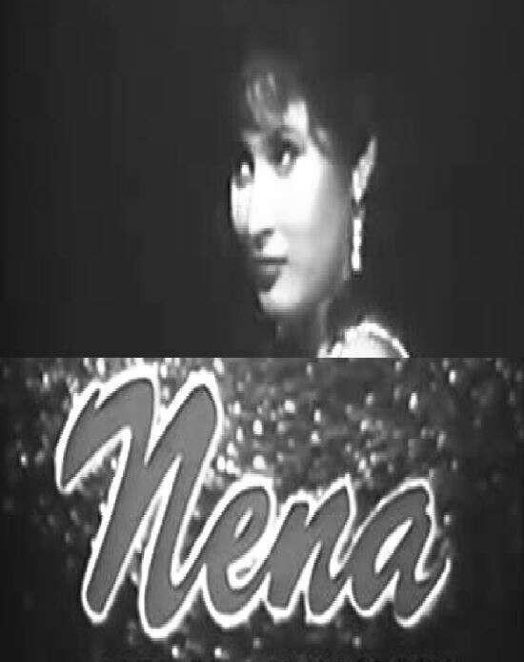
7. Bata, Bata… Pa’no Ka Ginawa? (1998) - Adaptation of Bautista's novel, directed by Chito S. Roño and starring Vilma Santos as Lea Bustamante.
https://youtu.be/_4QZ9KhOEck?si=_1cYCsyZ8xInpKbQ
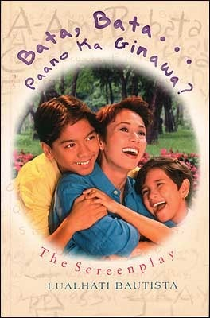

8. Gusto Ko Nang Lumigaya (2000) - Directed by Maryo J. de los Reyes. A political drama/thriller screenplay dealing with politics, personal interests, and social conflict.
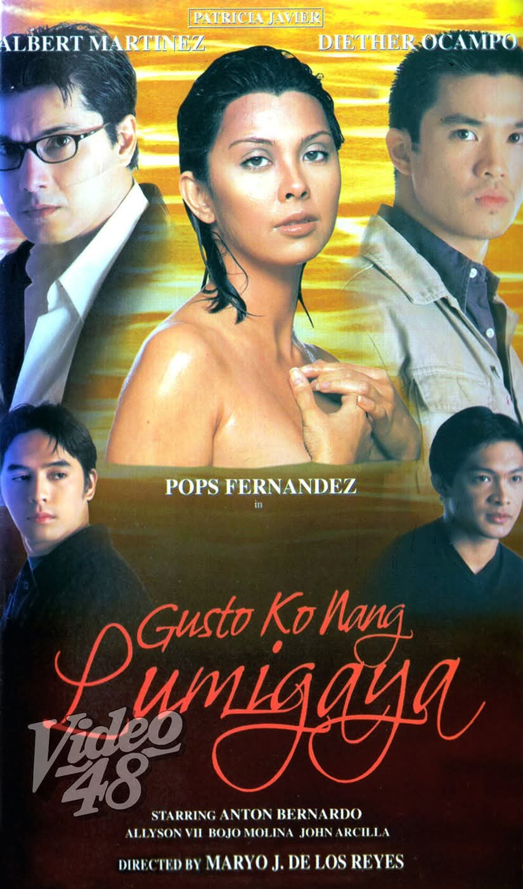
9. Sex Object (1985) - A socially critical screenplay addressing the objectification and exploitation of women.
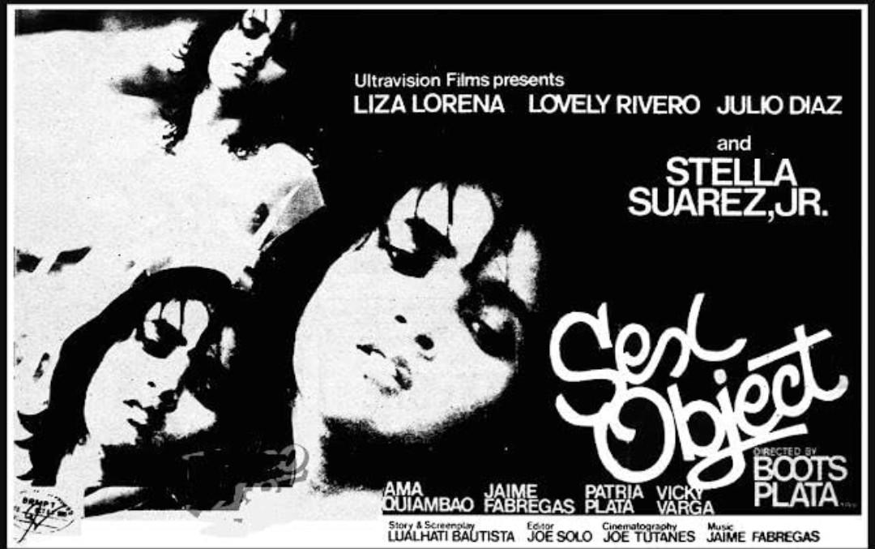

10. Dekada '70 - Screen adaptation of Bautista's novel about a family living through Martial Law and the political awakening of its members.
https://youtu.be/CtU69gBGXSU?si=TPmrzzcQzkFpZPIM
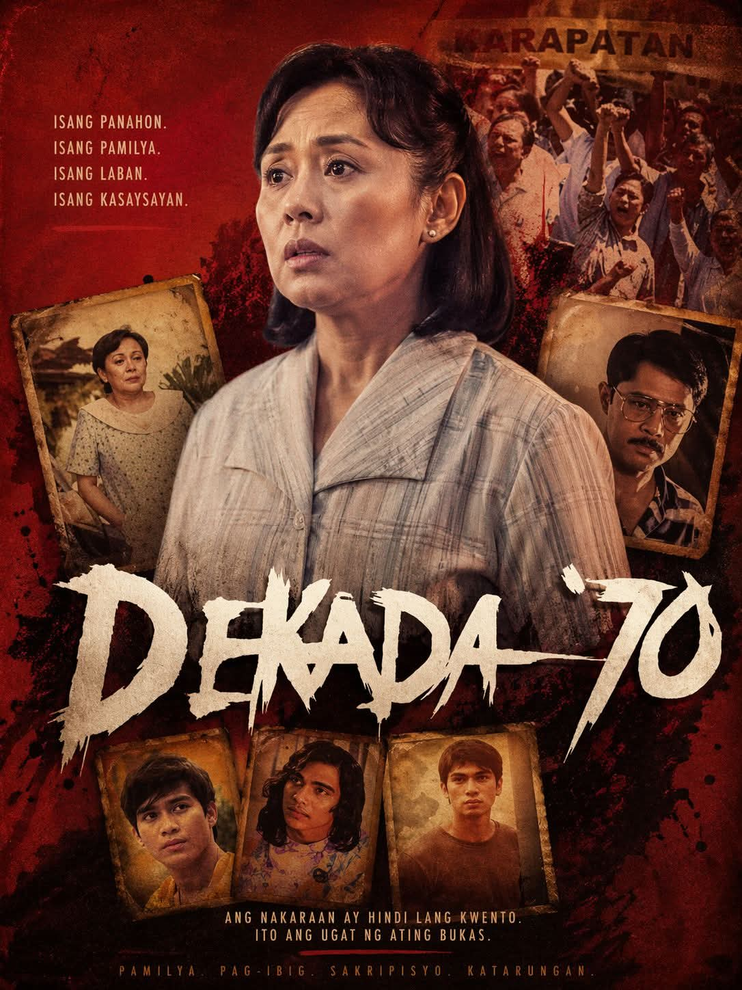

11. Isang kabanata sa Libro ng Buhay ni Leilani Cruzaldo (1987) - Television drama about the life of Leilani Cruzaldo; the work received recognition for television drama writing.

• Television Scripts •
1. Daga sa timba ng tubig (1975) - A socially conscious television drama; its presentation was significant enough to encounter censorship, reflecting Bautista's willingness to tackle controversial social issues.
2.. Balintataw—Labinglimang Taon (1987) - An episode of the television drama anthology Balintataw
3. Desaperasidos - Television adaption of Bautista's novel
4. Dear Teacher - Television drama co-written by Bautista
5. Mama -
6. Pira-pirasong Pangarap - Television drama concerning fragmented hopes and difficult personal circumferences.

• Links to External Publication •
https://www.goodreads.com/author/list/673490.Lualhati_Bautista
https://openlibrary.org/authors/OL314158A/Lualhati_Bautista
https://www.imdb.com/name/nm0062527/

• Links to Video/Interview •
https://youtu.be/G040z3MHf2M?si=2djERtW8jWL6mv0q

• Links to Awards/Recognition •
https://youtu.be/DHuovLJaCww?si=OrrC3_BjJGkf4KDU

Lualhati Bautista’s Biography

Lualhati Torres Bautista was born on December 2, 1945, in Tondo, Manila, and died on February 12, 2023, at the age of 77 at her home in Quezon City. Her cause of death was cancer. Lualhati Bautista was a writer, novelist, political activist, and social critic. She is one of the best known and foremost Filipina Novelists in the history of Contemporary Philippines Literature.

Bautista began writing at the age of 16, and her parents, who were both teachers, greatly influenced her passion for literature and writing. She started her writing career with Liwayway Magazine. Despite having no formal training in writing, her works gained recognition and inspired many readers. She was known for her honest realism, courageous exploration of Philippines Women's Issues during the Marcos era, and compelling Female Protagonists.

Bautista received several “Palanca Awards” for her literary works. Among her most notable novels are “GAPÔ”, “Dekada '70”, and “Bata, Bata... Pa'no Ka Ginawa?” (1980, 1983, and 1984). Throughout her career, she also served as Vice President of the Screenwriters Guild of the Philippines and headed the Association of Popular Novel Writers. She took Journalism in College but eventually dropped out before completing her freshman year because she wanted to focus entirely on writing.

Bautista's works belong to the modern and contemporary period of Philippine literature. Many of her significant works were written during periods of political and social change in the Philippines, particularly during and after the Martial Law era.

Parents
Father: Estaban Bautista
Mother: Gloria Torres

Educational Background
Institution | Year
Emilio Jacinto Elementary School | Graduated in 1958
Florentino Torres High School | Graduated in 1962
Lyceum of the Philippines | 1962

